**Exercise 1: Implementing the Singleton Pattern**

**Source Code:**

**Logger.java :**

**package** com.singleton;

**public** **class** Logger {

**private** **static** Logger *logger*=**null**;

**private** Logger() {

System.***out***.println("Logger is Created");

}

**public** **static** Logger getInstance() {

**if** (*logger* == **null**) {

*logger* = **new** Logger();

}

**return** *logger*;

}

**public** **void** log(String message) {

System.***out***.println("Log: " + message);

}

}

**Main.java:**

**package** com.singleton;

**public** **class** Main {

**public** **static** **void** main(String[] args) {

// **TODO** Auto-generated method stub

Logger log1 = Logger.*getInstance*();

Logger log2 = Logger.*getInstance*();

log1.log("This is from log1");

System.***out***.println(log1.hashCode());

log2.log("This is from log2");

System.***out***.println(log2.hashCode());//checking the hashcodes are same or not

//to check if (log1 == log2)

System.***out***.println(log1.equals(log2));

}

}

**Output:**

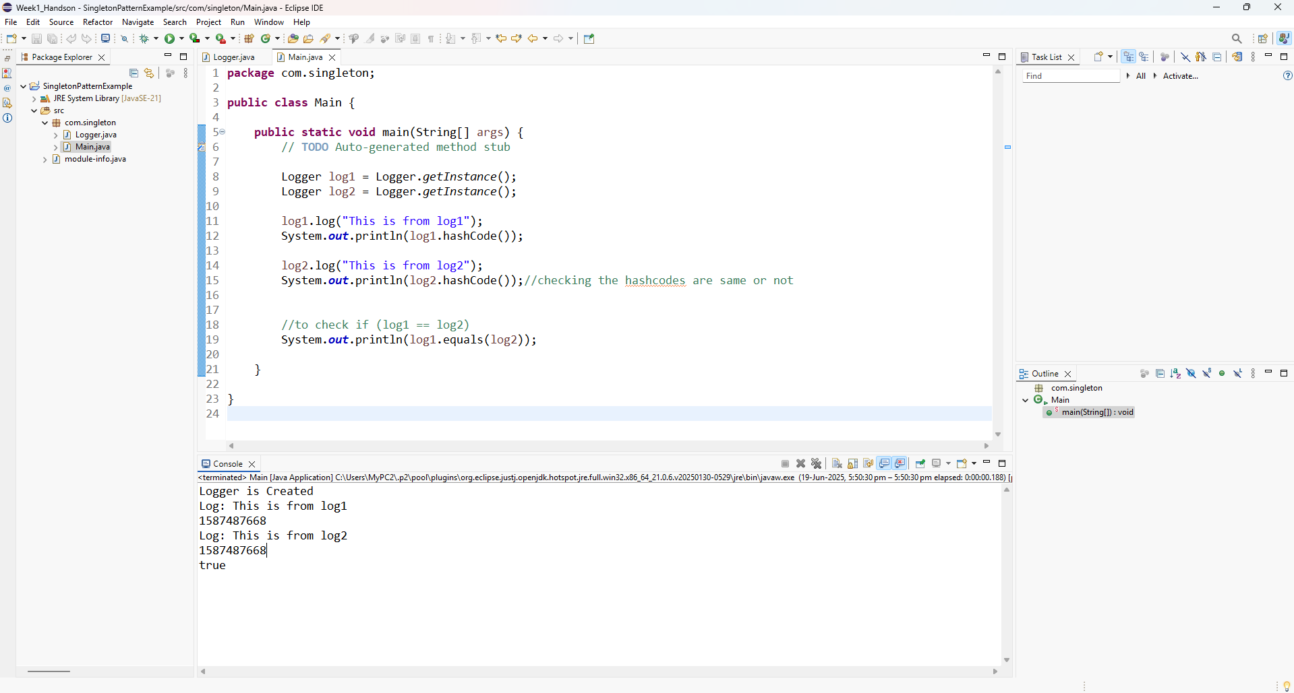

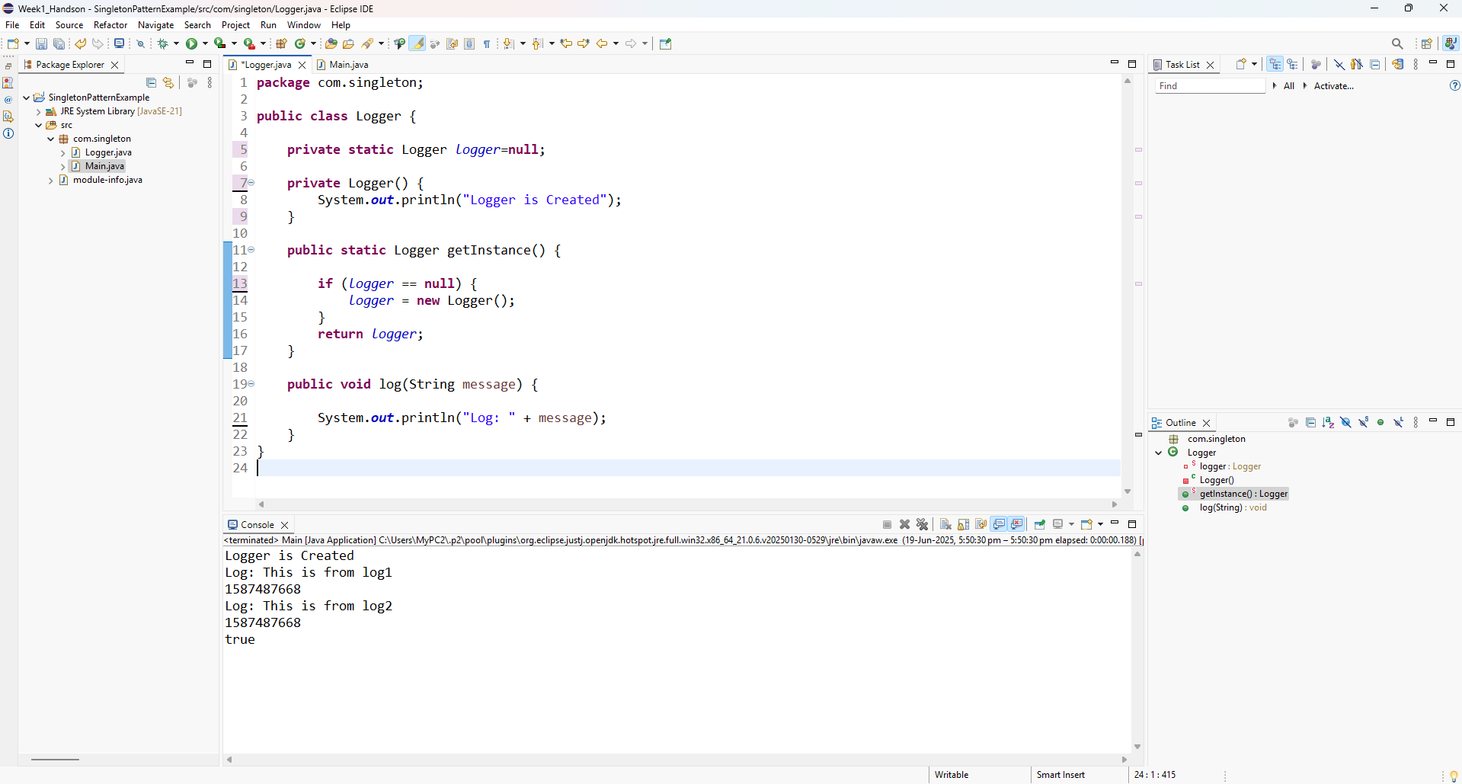

**Exercise 2: Implementing the Factory Method Pattern**

**Source Code:**

**Document.java**

**package** com.factory.documents;

**public** **interface** Document {

**void** open();

}

**DocumentFactory.java**

**package** com.factory.documents;

**public** **abstract** **class** DocumentFactory {

**public** **abstract** Document createDocument();

}

**ExcelDocument.java**

**package** com.factory.documents;

**public** **class** ExcelDocument **implements** Document {

@Override

**public** **void** open() {

System.***out***.println("Opening Excel document.");

}

}

**ExcelDocumentFactory.java**

**package** com.factory.documents;

**public** **class** ExcelDocumentFactory **extends** DocumentFactory {

@Override

**public** Document createDocument() {

// **TODO** Auto-generated method stub

**return** **new** ExcelDocument();

}

}

**PdfDocument.java**

**package** com.factory.documents;

**public** **class** PdfDocument **implements** Document {

@Override

**public** **void** open() {

System.***out***.println("Opening PDF document.");

}

}

**PdfDocumentFactory.java**

**package** com.factory.documents;

**public** **class** PdfDocumentFactory **extends** DocumentFactory {

@Override

**public** Document createDocument() {

// **TODO** Auto-generated method stub

**return** **new** PdfDocument();

}

}

**WordDocument.java**

**package** com.factory.documents;

**public** **class** WordDocument **implements** Document {

@Override

**public** **void** open() {

System.***out***.println("Opening Word document.");

}

}

**WordDocumentFactory.java**

**package** com.factory.documents;

**public** **class** WordDocumentFactory **extends** DocumentFactory {

@Override

**public** Document createDocument() {

// **TODO** Auto-generated method stub

**return** **new** WordDocument();

}

}

**FactoryMethodTest.java**

**package** com.factory.documents;

**public** **class** FactoryMethodTest {

**public** **static** **void** main(String[] args) {

// **TODO** Auto-generated method stub

DocumentFactory wordFactory = **new** WordDocumentFactory();

Document wordDoc = wordFactory.createDocument();

wordDoc.open();

DocumentFactory pdfFactory = **new** PdfDocumentFactory();

Document pdfDoc = pdfFactory.createDocument();

pdfDoc.open();

DocumentFactory excelFactory = **new** ExcelDocumentFactory();

Document excelDoc = excelFactory.createDocument();

excelDoc.open();

}

}

**Output:**

